Financial Institution Customer Onboarding Process –

Process Improvement Simulation Overview

The following instructions outline how to improve the *Onboard Customer to Financial Institution* process, by using Cloud-based simulation in Process 360 Live Design to analyze the process.

This process to ‘onboard’ a customer to a financial institution is currently taking too long, and is creating too many ‘false positives’ when checking the Blocklist. We also suspect there are too many ‘false positives’ when checking the PEP (Politically Exposed Persons) and S&E (Social & Environmental, or ‘sanctions’) lists. We are considering using automation to both decrease the ‘false positives’ for finding people on the lists, and decreasing the time it takes to do the check / screening.

# Quick Summary Reminder

Once you’re familiar with the detailed instructions below, this summary / reminder should help you remind yourself of what to do:

1. Check Out the diagram.



1. Review the Simulation Properties for the diagram and steps, as desired. You may want to focus on the ‘Check Blocklist’ and ‘On Blocklist?’ steps



Variables: Steps:

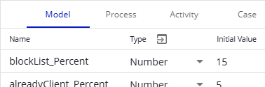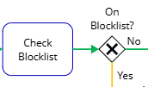

Check Blocklist time, using an expression:

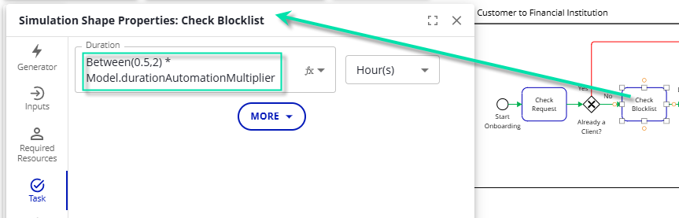

On Blocklist Gateway (Decision), using an expression:

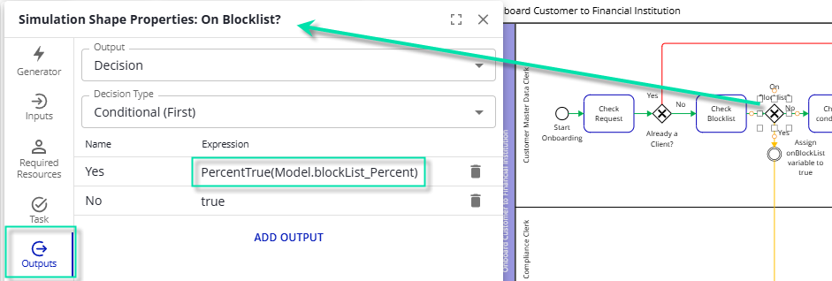

1. Run simulation in Trace Mode, showing the animation there and explaining it.



1. Save your simulation run; e.g., with a name of ‘As-is’. Close the Simulation Statistics (report / results) window.



1. Automate the Check Blocklist step

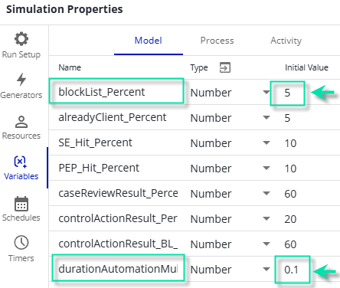

1. Run simulation.



***Optional:*** Run in ‘Trace’ mode to show the behavior with the change.

1. Save your simulation run; e.g., with a name of ‘Automate Blocklist.’. Close the Simulation Statistics (report / results) window.



1. Review the simulation results in the project: This has improved cost per case and overall time through the process by about 20-30%!

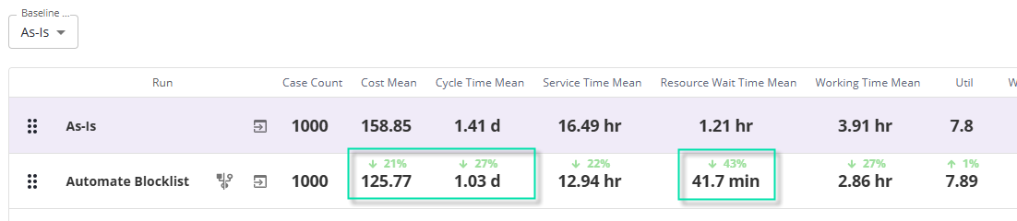

# Detailed Instructions

The following suggested steps should work to show simulation capability:

1. Check Out the diagram (remember to undo check-out and/or revert when done!)
2. Review the process and simulation setup.
   1. ***Without*** *anything selected*, click the ‘Simulation Properties’ button and review Run Setup, Generators, and Resources. Some key points to consider / review:



* + 1. We’ll run simulation for over a year.
    2. We introduce cases from ‘External Data’ – a list of what customers we needed to onboard during a particular period of time.
    3. We have various Resources defined to do the work (e.g., 4 Customer Master Data Clerks, 1 Compliance Clerk, and 1 Customer Master Data Team Lead).
    4. We’ve defined Variables at both the ‘Model’ (global or shared) and ‘Case’ (each unique case caries its own value). The Model variables provide a ‘*control panel*’ of sorts, that allows quickly changing model behavior from one place.

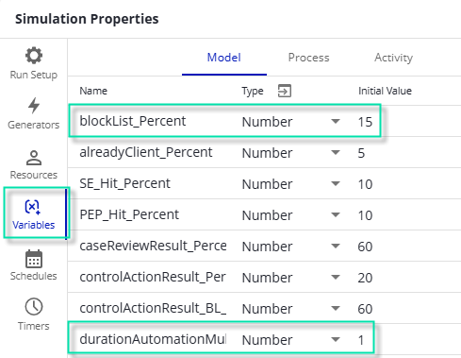

* 1. Review process flow, Activity times, decision percentages, etc. We’ll be focusing on improving the ‘Check Blocklist’ step by automating it. Two key simulation Properties to understand / review:
     1. The ‘Task’ duration of the ‘Check Blocklist’ step: Uses the ‘Model’ variable ‘durationAutomationMultiplier’ to shorten (or lengthen) the specified duration by some amount (e.g., if the durationAutomationMultiplier is 0.1, then the duration will be only 10% of the time chosen, or 90% faster):



* + 1. The ‘On Blocklist?’ decision (Exclusive Gateway): Uses the ‘Model’ variable ‘blockList_Percent’ to control the probability of a customer being on the Block List:



1. Run simulation in Trace Mode



* 1. Click the ‘run simulation in trace mode’ button



* 1. Click the ‘Play’ button to run simulation, adjusting speed as needed, to get a sense for *how the process behaves*.



* 1. Click Finish to complete the simulation run.



1. Review the Simulation Statistics report.
   1. Talk about various statistics gathered on the Processes tab; Cost - Mean, Cycle (Lead) Time, etc.



* 1. Click on the Resources tab, and note that while there’s a wait queue and waiting time, utilization looks reasonable.



1. Save your simulation run; e.g., with a name of ‘As-is’. Close the Simulation Statistics (report / results) window.



1. Automate the Check Blocklist step which will reduce the amount of ‘false positives’ we receive on the blocklist (fewer cases will be flagged as being on the blocklist), and it will also greatly reduce the amount of time necessary to perform the task.



Note: We are assuming that a human will still have to review every result, and will spend far less time to do so. We probably could remove the human from this step altogether.

* 1. Make sure nothing is selected and click Simulation Properties.
  2. Click the Variables Page.
  3. Click Model tab.
  4. Change the ‘blockList_Percent’ from 15 to 5.
  5. Change the ‘durationAutomationMultiplier from 1 to 0.1



Click Done to save your changes.



1. Run simulation.



***Optional:*** Run in ‘Trace’ mode to show the behavior with the change.

1. Save your simulation run; e.g., with a name of ‘Automate Blocklist.’. Close the Simulation Statistics (report / results) window.

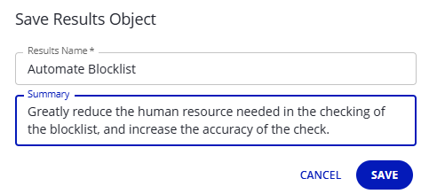

1. Review the simulation results in the project: This has improved cost per case and overall time through the process by about 20-30%!



1. ***Optional:*** Remove the resource from the Check Blocklist step, run simulation, save the simulation results, and check the difference:
   1. Select the ‘Check Blocklist’ step, click the Simulation Properties button, click the ‘Required Resources’ page, and click the trashcan to delete the resource from the step:

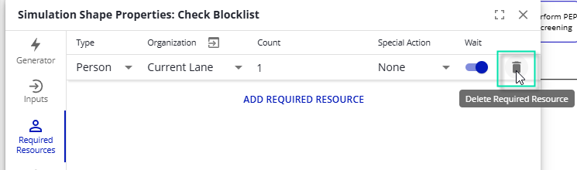

* 1. Run simulation.



* 1. Save your simulation run; e.g., with a name of ‘Auto BL No Human.’. Close the Simulation Statistics (report / results) window.



* 1. Review the simulation results in the project: This has made very little difference in overall process behavior:

